What is a Local Landscape Character Assessment (LLCA)?
Through landscape character assessment we can gain an understanding of what makes up the rich and diverse character of Cornwall, and which elements are important or have particular value.

A Local Landscape Character Assessment (LLCA) takes the overarching Cornwall wide Landscape Character Assessment as a template, and adds a much greater level of detail, describing the local landscape character at a parish scale.
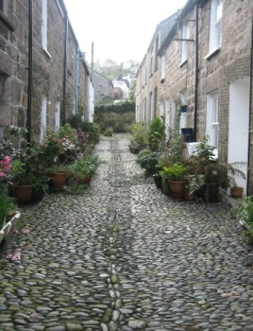
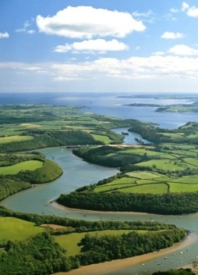
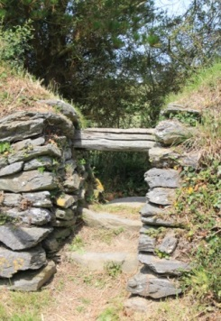
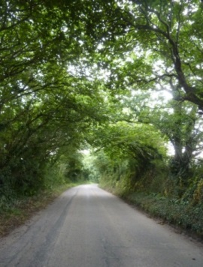
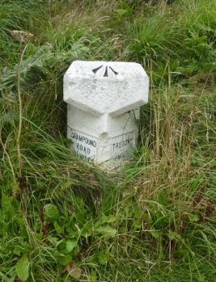
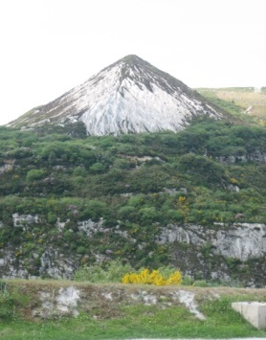

If we don’t understand and objectively record what makes our landscape special and why, then we have no way to protect or enhance the special qualities and features that come together to make up the diverse and locally distinctive landscapes of Cornwall. Recording the evidence of this character is the role of a LLCA.

What is the benefit of an LLCA as part of a Neighbourhood Plan?
All landscapes change over time through the influence of nature and man, and change should not always be seen as negative. If we understand which elements give us the character we all value so greatly, we can positively plan and sensitively integrate future development into the landscape.

As part of your Neighbourhood Plan, LLCA will provide you with a
- record of the character of the area prepared by the local community describing the character and value of the local landscape, its historic, ecological, and cultural qualities,
- document of local evidence which can objectively inform decisions on the environmental implications of development proposals
- factual evidence base to inform policy within your Neighbourhood Plan
- mapping to identify designated and protected landscapes, natural and built features
- understanding of landscape features and issues of key importance to the local community
- a document to inform future land management decisions.

What is the process of creating an LLCA?
The LLCA must be a factual evidence base of landscape character, and is prepared by the local community. It is not a quick process, but the length of time it will take to complete will largely depend upon the scale of your

Neighbourhood Plan area, and the number of volunteers who come forward to carry out the field assessments. These volunteers need no specialist training, just the love of the environment and a willingness to walk around the Parish and record the character on pre prepared field assessment sheet.

Preparing an LLCA Stage 1- Character Assessment has 8 steps as shown in the table below

NDP Toolkit Stages | LLCA Development | Who gets involved?
Stage 1 & 2a | Step 1 - Initiating an LLCA  Planning the development of the LLCA to tie in with the overall programme for the Neighbourhood Plan | Parish Council, Neighbourhood Plan Steering Group
Stage 2a | Step 2 – Creating an LLCA core group  Identify and brief individuals to coordinate the development of the LLCA. Establish programmes and lines of communication | Neighbourhood Plan Steering Group, local community
Stage 2a | Step 3 – Initial information gathering  Research to establish existing environmental details/records | LLCA Core Group
Stage 2a | Step 4 - Briefing the Volunteers  Provide training to volunteers to enable them to carry out field work assessments | LLCA Core Group and community volunteers
Stage 2a | Step 5 – Field survey to record local character  Getting out into the landscape to record the character of the area | LLCA Core Group and community volunteers
Stage 2b | Step 6 - Preparing the draft LLCA  Bringing together all of the existing environmental information, the field assessments and photographs to create a draft document | LLCA Core Group and Neighbourhood Plan Steering Group
Stage 2b | Step 7 - Presenting the draft LLCA to the community  Community consultation to add important detail of how and what the community values about their landscape, and opportunity to present the draft for comment  It is recommended that this consultation is run alongside community engagement on the wider NDP, rather than as a separate consultation exercise. | LLCA Core Group and Neighbourhood Plan Steering Group, local community
Stage 2c | Step 8 - Finalise the LLCA  Bring the document together – add to the draft, comments made by the public at the consultation event, and new information gathered on what the community value about the landscape of the Parish | LLCA Core Group and Neighbourhood Plan Steering Group

LLCA Stage 2 – Edge of Settlement Assessment – is a further piece of work which looks at the edges of the settlements within the NDP area, and how the buildings meet the wider landscape. This assessment can either be detailed, looking at the capacity of individual fields to accept new development, or a lighter touch looking at the overall sensitivity to change of the landscape character and views around the settlement. The completed document can be used to inform a direction of growth for the settlement, or as part of the much larger process of land allocation.

2007 Landscape Character Assessment which divides Cornwall into 40 Landscape Character Areas details of which can be found at www.cornwalllandscapes.org.uk

